# FW- HW Integration Document

## Document details

This document includes the HW required information in order to implement the specific application FW for M2MCommBoard_V2p1 PCB.

***Creation date***: 20 February 2018 ***Last modification date***: 23 February 2018

***Revision***: 2.0

***Contributors***: Francisco LunaSINAPSE-PACO

***Revision history:***

|  |  |  |
| --- | --- | --- |
| Date | Contributor | Changes |
| 20-Feb-18 | Fco. Luna | Initial release. |
| 23-Feb-18 | Fco. Luna | * Included references for Tables and Images * Changes in *Table 2: PCB reference* * Changes in *Table 4: Pinout description*: STATUS and PWRKEY definition changed. * Changes in *Table 3: Brief Peripherals description*: included QUECTEL BC95 |

**Table 1: Revision history**

## Microcontroller

|  |  |  |  |  |  |
| --- | --- | --- | --- | --- | --- |
| **HW PCB** | M2MCommBoard_V2p1 | **Revision** | 2p3 |  |  |
| **Microcontroller** | STM32F215RET | **Int.RAM Size** | 128KB | **Int. EEPROM Size** | 512Kb FLASH |

**Table 2: PCB reference**

### Micro Footprint & pinout

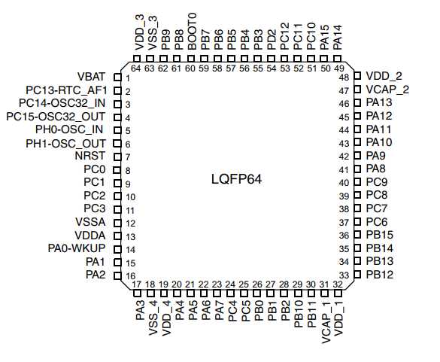

**Image 1: STM32F215RET footprint**

## Peripherals

|  |  |  |  |  |  |
| --- | --- | --- | --- | --- | --- |
| **Peripheral** | **Description** | **Interface** | **Microcontroller Interface** | **Pins** | **Comments** |
| QUECTEL M95 | GPRS interface | UART | USART6 | PC6, PC7 | (a)(c)(d) |
| GPIO | PA11, PA12.  PA8, PA15, PC1, PC2 |
| QUECTEL BC95 | NB interface | UART | USART6 | PC6, PC7 | (a)(c)(d) |
| GPIO | PA11, PA12.  PA8, PA15, PC1, PC2 |
| QUECTEL BG96 | GPRS, LTE, NB interfaces | UART | USART6 | PC6, PC7 | (b)(c)(d) |
| USART2 | PA2, PA3 |
| GPIO | PA11, PA12.  PA8, PA15, PC1, PC2 |

**Table 3: Brief Peripherals description**

1. USART6 is the main USART interface used for data transmission and AT command communication.
2. USART2 used for outputting GNSS data or NEMA sentences.
3. Refer to *Annex 1: Pinout Description* for a complete pins definition.
4. Only one QUECTEL transceiver could be mounted at the same time
5. For more details, refer to *Table 4: Pinout description.*

## Microcontroller Configuration

The following image shows the microcontroller configuration. The signal names appear as they are routed in PCB design. These names may change depending on the PCB.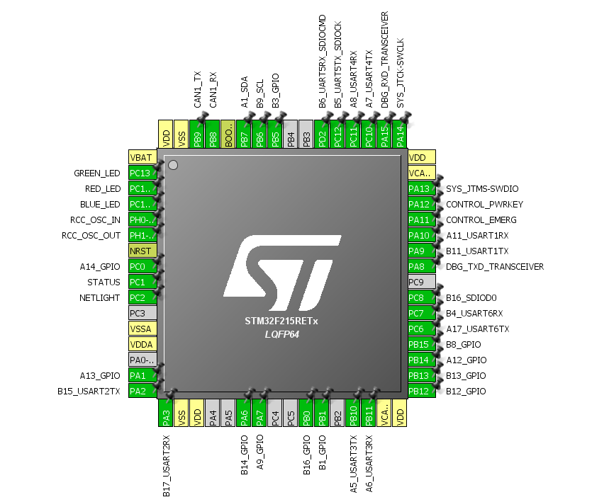

**Image 2: STM32F215RET Microcontroller configuration**

## Annex. 1: Pinout Description



**Image 3: Microcontroller pinout**

|  |  |  |  |
| --- | --- | --- | --- |
| **Signal Name** | **Microcontroller**  **PIN / NAME** | **Configuration** | **Comments** |
| PA0 | 14 / PA0-WKUP | - | (3) |
| A13_GPIO | 15 / PA1 | General Purpose I/O | (1) |
| B15_USART2_TX | 16 / PA2 | USART2 Data Transmit | To GNSS RXD in QUECTEL through TXB0106 |
| B17_USART2_RX | 17 / PA3 | USART2 Data Receive | To GNSS TXD in QUECTEL through TXB0106 |
| PA4 | 20 / PA4 | - | (3) |
| PA5 | 21 / PA5 | - | (3) |
| B14_GPIO | 22 / PA6 | General Purpose I/O | (1) |
| A9_GPIO | 23 / PA7 | General Purpose I/O | (1) |
| DBG_TXD_  TRANSCEIVER | 41 / PA8 | General Purpose Input | From DBG_TXD in QUECTEL through TXB0106 |
| B11_USART1_TX | 42 / PA9 | USART1 Data Transmit |  |
| A11_USART1_RX | 43 / PA10 | USART1 Data Receive |  |
| CONTROL_EMERG | 44 / PA11 | General Purpose Open Drain | To CONTROL_EMERG in QUECTEL (4) |
| CONTROL_PWRKEY | 45 / PA12 | General Purpose Open Drain | To CONTROL_PWRKEY in QUECTEL (5) |
| SWDIO | 46 / PA13 | JTMS-SWDIO | Programmer interface |
| SWCLK | 49 / PA14 | JTCK-SWCLK | Programmer interface |
| DBG_RXD_  TRANSCEIVER | 50 / PA15 | General Purpose Input | From DBG_RXD in QUECTEL through TXB0106 |
| B16_GPIO | 26 / PB0 | General Purpose I/O | (1) |
| B1_GPIO | 27 / PB1 | General Purpose I/O | (1) |
| PB2 | 28 / PB2 | - | (3) |
| PB3 | 55 / PB3 | - | (3) |
| PB4 | 56 / PB4 | - | (3) |
| B3_GPIO | 57 / PB5 | General Purpose I/O | (1) |
| B9_SCL | 58 / PB6 | I2C1 Clock |  |
| A1_SDA | 59 / PB7 | I2C1 Data bus |  |
| CAN1_RX | 61 / PB8 | CAN1 Data Receive |  |
| CAN1_TX | 62 / PB9 | CAN1 Data Transmit |  |
| A5_USART3_TX | 29 / PB10 | USART3 Data Transmit |  |
| A6_USART3_RX | 30 / PB11 | USART3 Data Receive |  |
| B12_GPIO | 34 / PB12 | General Purpose I/O | (1) |
| B13_GPIO | 34 / PB13 | General Purpose I/O | (1) |
| A12_GPIO | 35 / PB14 | General Purpose I/O | (1) |
| B8_GPIO | 36 / PB15 | General Purpose I/O | (1) |
| A14_GPIO | 8 / PC0 | General Purpose I/O | (1) |
| STATUS | 9 / PC1 | General Purpose Input | From STATUS in QUECTEL (6) |
| NETLIGHT | 10 / PC2 | General Purpose Input | From NETLIGHT in QUECTEL |
| A17_USART6_TX | 37 / PC6 | USART6 Data Transmit | To GPRS RXD in QUECTEL through TXB0106 |
| B4_USART6_RX | 38 / PC7 | USART6 Data Receive | To GPRS TXD in QUECTEL through TXB0106 |
| SDIO_D0 | 39 / PC8 | SDIO Data Line |  |
| A7_USART4_TX | 51 / PC10 | USART4 Data Transmit |  |
| A8_USART4_RX | 52 / PC11 | USART4 Data Receive |  |
| B5_UART5TX_SDIOCK | 53 / PC12 | USART5 Data Transmit | (2) |
| AF: SDIO Clock |
| BLUE_LED | 2 / PC13 | General Purpose Output | RGB LED interface |
| RED_LED | 3 / PC14 | General Purpose Output | RGB LED interface |
| GREEN_LED | 4 / PC15 | General Purpose Output | RGB LED interface |
| UART5RX_SDIOCMD | 54 / PD2 | USART5 Data Transmit | (2) |
| AF: SDIO CMD |

**Table 4: Pinout description**

1. General Purpose pins have a different application depending on BaseBoard in use. Please, check the specific HW-FW BaseBoard document.
2. Depending on BaseBoard in use, this pin could be used as UART5 interface or SDIO interface.
3. Not connected.
4. This pin is RESET_N pin in QUECTEL BG96.
5. Only in QUECTEL M95. Unused for QUECTEL BC95 & BG96.
6. Unused in QUECTEL BC95.

## Annex 1: Datasheets & App. Notes

## Microcontroller

* [STM32F215XX – STMicroelectronics] <http://www.st.com/content/st_com/en/products/microcontrollers/stm32-32-bit-arm-cortex-mcus/stm32-high-performance-mcus/stm32f2-series/stm32f2x5/stm32f215re.html>